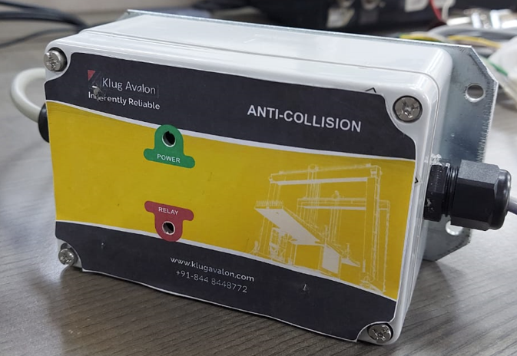**Anti-collision detection system**

**Features:**

1. System works for wide AC operating range

(110V to 230V).

1. Adjustable safety distance.
2. Indication.
3. Power Indication LED.
4. Relay status indication LED.
5. Potential free relay output.
6. Ease of installation.

**Enclosure Dimensions:**

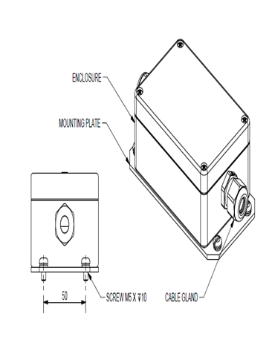

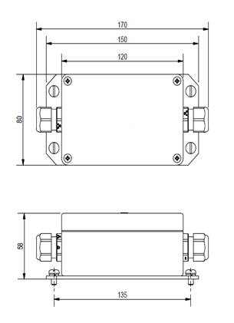

**Sensor Dimensions:**

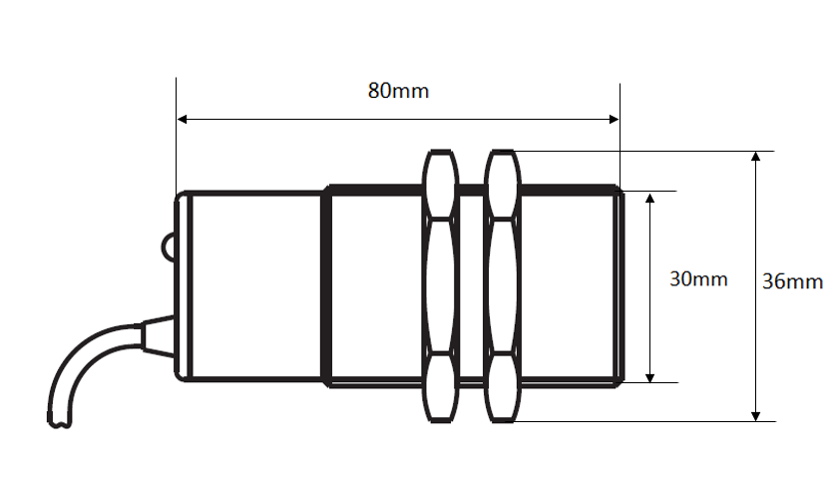

**Technical Specification of Anti-collision System:**

1. Input: AC (110V TO 230 V).
2. Current Consumption: 100 ma.
3. Power Consumption: 1.2W.
4. Max relay switching current: 5A.
5. Adjustable safety distance: 1 to 5 Meters.
6. Enclosure Dimensions: 170 x 80 x 58 mm.
7. Enclosure Protection Class: IP65.
8. Operating Temperature: 0°C to 55°C.
9. Storage Temperature: -20°C to 80°C.
10. Power indication.
11. Relay status indication.